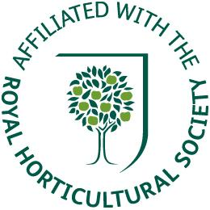
COLLINGHAM AND DISTRICT GARDENING ASSOCIATION

Chairman David Tongue

MEMBERSHIP

Benefits of membership :-

Monthly meetings with interesting and informative talks on gardening and related topics.

Visits to places of interest in the summer months.

A very reasonable Annual Subscription for Members and a Meeting Fee that includes refreshments.

The Collingham and District Gardening Association is affiliated to the Royal Horticultural Society and Members can get free advice from the RHS using the Affiliation Number.

A raffle is held at meetings for excellent prizes.

Two ‘Shows’ are held per year, the Spring Flower Show in April and the Autumn Show jointly with the W I in September to enable you to compete with your peers.

Discount opportunities are available through local businesses.

Members have the chance to socialise with other gardeners and discuss their successes and possibly failures and in doing so pick up a few tips.

For further information or to become a member contact the Secretary by Email cdga43@gmail.com or phone 01522 778600

